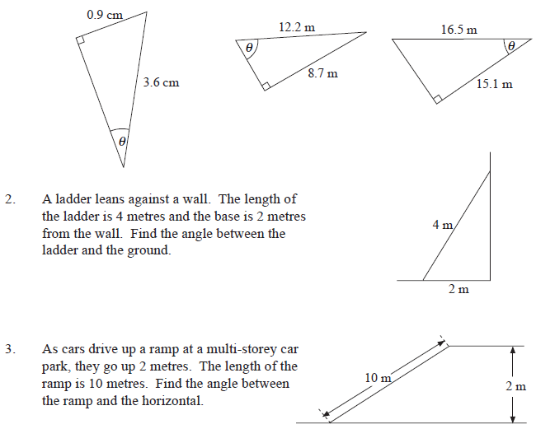
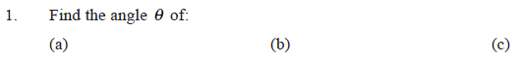
Missing Angle Problems – Trigonometry (Answers to 1 dec. place)





Missing Angle Problems – Trigonometry (Answers to 1 dec. place)

